|  |  |  |
| --- | --- | --- |
|  | Available online at www.sciencedirect.com |  |
|  |
| AASRI Procedia 3 ( 2012 ) 674 – 679 |

2012 AASRI Conference on Modeling, Identification and Control

Research on bird strike simulation of composite leading edge

Yijing GUOa*, Pinghui Jiaa, Guanxin Hongb

*aPO.BOX 7-13, No.37 XUEYUAN Road, HAIDIAN DISTRICT, Beijing, 100191, China bZHIXING 308, No.37 XUEYUAN Road, HAIDIAN DISTRICT, Beijing, 100191, China*

**Abstract**

The paper studies the bird strike against composite material tail leading edge under Chinese HB7084-94 condition, including material failure process, by using explicit finite element method. SPH grid free method is taken to describe birds splashing during the strike. The calculation results show that, the original design composite structure could not meet the requirements of standard HB7084-94 towards the aircraft vertical tail anti-bird impact performance. The optimized design increases the ply number of the leading edge from 6 to 22. With a weight cost of 2.957Kg, the optimized design could meet the standard.

© 2012 Published by Elsevier B.V. Selection and/or peer rev[iew under responsi](http://creativecommons.org/licenses/by-nc-nd/3.0/)bility of American Applied Selection and/or peer review under responsibility of American Applied Science Research Institute Science Research Institute

*Keywords:* Simulation; Explicit finite element; Bird strike; Composite

**1.Introduction**

Bird strike is the collision of aircraft with birds when flying at high speed. This sudden and multiple accidents cause serious damage to the aircraft structure, and a direct threat to flight safety. With the development of the aviation industry, anti-bird impact design factors are introduced in the aircraft design phase. Through simulation analysis, aircraft structure optimization experiments costs can be greatly reduced and the design cycle can be shortened.

* Corresponding author. Tel.: +86-158-1100-8081.   
*E-mail address:* guo.yijing@yahoo.cn.

2212-6716 © 2012 The Authors. Published by Elsevier B.V. Open access under [CC BY-NC-ND license.](http://creativecommons.org/licenses/by-nc-nd/3.0/) Selection and/or peer review under responsibility of American Applied Science Research Institute doi: 10.1016/j.aasri.2012.11.107

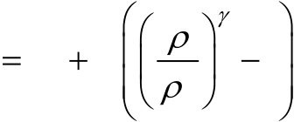

*Yijing GUO et al. / AASRI Procedia 3 ( 2012 ) 674 – 679*  675

Many domestic and foreign scholars have embarked on a great deal of research work [1], by comparing numerical calculation and the real experiment to verify the reliability and efficiency of explicit finite element method in handling the bird strike issue [2] .

Using the explicit finite element analysis software PAM-CRASH, the paper establishes the complete impact dynamic structure model of the aircraft tail. According to the standards HB7084-94, the performance under bird impact is analyzed and the optimization the tail leading edge structure is done.

**2.Analysis method**

*2.1.The calculation model*

A common point for traditional finite element methods of bird strike simulation is that, just after the strike, the bird element unit twists and causes the decrease of precision. As time goes on, the analysis will be ended by error. The experiment proves that the bird shows hydrodynamic behavior when crash with an aircraft at a large flight speed [3]. Among the various methods to simulate the bird, SPH (Smoothed Particle Hydrodynamics) method compared to Lagrange and ALE (Arbitrary Lagrange Eulerian) method, can better describe the behavior of the birds crashing and splashing [4]. The paper follows Murnaghan equation [5], modeling on 12800 SPH unit. The bird constitutive equation is:

|  |  |  |  |  |
| --- | --- | --- | --- | --- |
| *P* | *P* 0 | *B* | 1 | *(1)* |

0

The leading edge skins, front and rear beams, walls and ribs of the aircraft tail are variable thickness composite. And the leading edge skins uses honeycomb sandwich materials for strengthen. The beam connector uses titanium alloy materials. The connection between the components is rivet.

For the mechanical performance of different materials, different models are established. For composite structures modeling, at first the mechanical properties and failure characteristics of the monolayer is defined, and then simulate the material macroscopic properties according to the number and direction of layer.

Tail leading edge will be directly affected by the impact of the bird; it is constituted by composite skin and honeycomb reinforcing structure. Skin takes shell element model. The honeycomb is under pressure load as a whole, so it uses solid element for model. The connection mode between skin and honeycomb is tied, the shell and the solid element use fusion node for simplification. The leading edge structure is shown in table 1.

Table 1. Leading edge skin information

|  |  |
| --- | --- |
| Leading edge part | Thickness [mm] |
| Upper skin  Lower skin  Honeycomb  diaphragm | 0.996  0.996  12.6  1.826 |

676  *Yijing GUO et al. / AASRI Procedia 3 ( 2012 ) 674 – 679*

*2.2.Bird strike analysis*

The established finite element model of the tail is shown as below. Various components are joined into an organic whole through fasteners. The impact position is at the third diaphragm of the leading edge. According to different requirements, the types of fasteners selected between parts are also different. In the analysis model, the stringer is relatively far away from the impact location, so tied connection mode is used to simulate the role of strengthen for the skin.

According to standards HB7084-94 for the anti-bird impact of the tail structure, bird selects 3.6Kg, with both ends hemisphere, the intermediate cylindrical simplified model, diameter 18cm. it hits the vertical tail leading edge with the speed 114m/s. Bird strike process usually take millisecond, so it is set 10ms for the calculation time.

Contact is a mathematical model of the bird and the associated structure in time marching, and therefore it needs to define the contact between bird and the vertical tail leading edge. The bird uses SPH model, while the tail structure belongs to the traditional Lagrange unit. So in PAM-CRASH asymmetric contact is defined. Bird is the slave contact part and the leading edge master part.

Tail leading edge, the front beam and the ribs are connected by fasteners. But during the crash, the first to be hit structure will be deformed, and then impact the subsequent structures. That is, the tail leading edge, the front beam and the rib panel may be generated in a collision with each other under large deformation, resulting penetration. To simulate this interaction, self contact between these parts is defined.

*2.3.optimization*

Based on the simulation method above, the optimization of the tail leading edge structure is studied through computer-aided means. Taking into account the bird impact load, the leading edge and the front beam are mainly exposed to compressive load which is perpendicular to the surface. In order to meet the design requirements, we consider the following method: maintain the leading edge composite material, gradually increase the thickness of the leading edge. To save the optimization time, the model is simplified. The main parts which undertake the loads are kept in the simplified model. It includes: the leading edge, the 2nd, 3rd, and 4th diaphragms of the leading edge, front and rear beam, the 1st to 4th ribs, walls and strengthen stringers. Keep the connection mode of these parts, the constraints and calculation settings unchanged.

**3.Results and discussion**

*3.1.Bird strike analysis result*

The calculation results show that, in the pre-impact process, the bird is much softer than the structure, so large deformation and fragmentation occurs, and the bird body is divided into three parts by the leading edge, and the main weight concentrates in the middle part. Due to inertia, the middle part continues to fly into the wing box, contacts the front beam and crash on it. During the impact, the leading edge caves under the strong pressure of the bird, and pits the 3rd diaphragm, results the failure of the diaphragm. A hollow is formed is the middle of the leading edge. The bird penetrates the leading edge.

As can be seen in the figure, at 1ms after the contact to the leading edge, the contact force comes to the peak. At this time, there is still resistance from the 3rd diaphragm to the leading edge; the force does not decline rapidly to zero. At 1.9ms, the bird contacts the front beam, and the contact force comes to the maximum at 3ms. After that time, with the failure of the front beam and the 3rd diaphragm, the contact force is gradually reduced to zero.

*Yijing GUO et al. / AASRI Procedia 3 ( 2012 ) 674 – 679*  677

It should be noted that the failure mode of the leading edge skin and the diaphragm is not the same. For the leading edge skin and the front beam, the main load is extrusion and bending which is perpendicular to the surface due to the bird. So the damage mode is bending shear injury. For the 3rd diaphragm and the 3rd rib, the major loads are passed from the leading edge skin and the front beam, results in pressure instability failure.

|  |  |
| --- | --- |
|  |  |

Fig. 1. Failure modes of the leading edge and the front beam

|  |  |  |  |
| --- | --- | --- | --- |
|  |  |  |  |

Fig. 2. Failure modes of the 3rd diaphragm and rib

As can be seen from the Fig.1 and Fig.2, the leading edge is knocked through and wears a breach of 24cm long. The 3rd diaphragm is squeezed to failure. The bird crashes through the leading edge skin and hits the front beam, results the broken of the beam. The structure absorbs energy during the deformation. The following Fig.3 shows the increase energy of the leading edge.

678  *Yijing GUO et al. / AASRI Procedia 3 ( 2012 ) 674 – 679*

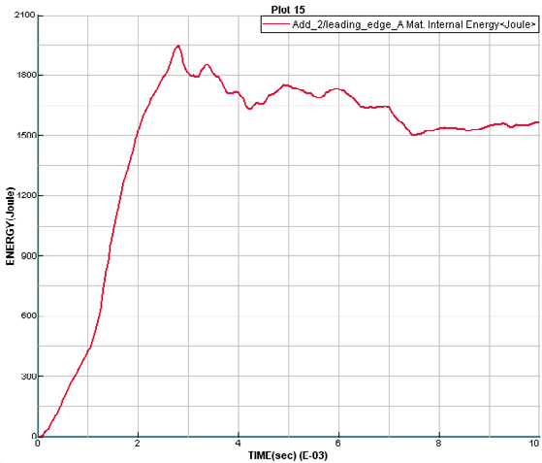

Fig. 3. Increase energy of the leading edge

*3.2.The optimization results*

In the original design, the overlay of leading edge composite is [45/45/0/0/45/45]. After 8 tests, it is found that when the layer number of the leading edge skin increases to 22, the leading edge could not be knocked through. The new leading edge layer is: [0/-45/90/45/-45/90/45/0/-45/45/0/0]. Optimized anti-bird strike performance is shown in Fig.4:   
 The thickened leading edge is partly broken during the impact. But majority of the bird residual weight is dispersed into the surrounding space, which prevents further damage to the front beam. The thickness of the leading edge after the optimization is 3.653mm. Compared to the original design, optimized design weight cost is 2.957Kg.

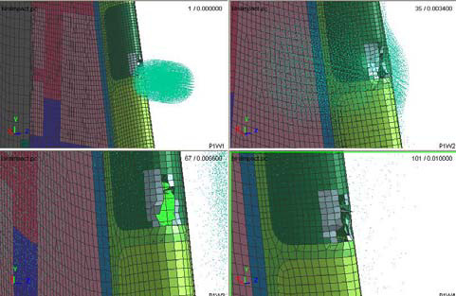

Fig. 4. the response of optimized leading edge

**4.Conclusions**

Based on the results of the calculations above, it can be concluded:

*Yijing GUO et al. / AASRI Procedia 3 ( 2012 ) 674 – 679*  679

1) During impact, the bird is quickly splashed into fragmentation, which is a similar physical phenomenon. Meaning that the usage of Murnaghan constitutive equation is available.

2) Composite vertical tail leading edge and the strengthening honeycomb material breakdown during bird impact. Because of the absorption by the deformation of leading edge and honeycomb material, the kinetic energy of the bird is reduced. The broken bird speed drops from 114m/s to 90m/s.

3) After the impact of the leading edge, the leading edge deformed and extruded the 3rd diaphragm. The composite is hit by the broken bird. Under the peak impact force up to 40KN, the front beam is breakdown. The result does not meet the requirements of Chinese aviation industry standard HB7084-94.

4) In the impact area, there are 53 fasteners failure, mainly in the area of the skin, the stringer and the diaphragm connecting.

5) Through the optimization, it shows that the method of increasing the material thickness could makes the vertical tail meet the requirements, but leads to weight cost 2.957Kg, weight cost ratio 8.43%.

**References**

[1]Robert R.Boroughs. High speed bird impact anal-ysis of the Learjet 45 windshield using DYNA3D[C]

AIAA-98-1705

|  |  |  |  |
| --- | --- | --- | --- |
| [2]Alessandro Airoldi | |  | Davide Tagliapietra. Bird impact simulation against a hybrid composite and metallic |
| ver-tical stabilizer[C] |  | AIAA01-25151. |

[3]J.S.Wilbeck, J.P.Barber, Bird impact loading, The Shock and Vibration Bulletin[J], Vol. 48, Part 2, Sept.1978, pp. 115-122.

[4]Vijay K. Goyal, Carlos A. Huertas et al. Robust Bird-Strike Modeling Based on SPH Formulation Using LS-DYNA[C] AIAA 2006-1878.

[5]ESI Group PAM—CRASHTM 2006 Solver Notes Manual[Z] Paris France 2006.